# Data Centric RAD

## Lab 1 MySQL Review

### Part 1

* Get superheroes.sql from Moodle.
* Start Wamp by double-clicking on the Wamp icon on the desktop.
* Then click on the Hidden Icons button, and the Wamp Icon.



* Then click on the MySQL console as shown, and when asked for a password just press ‘Enter’.

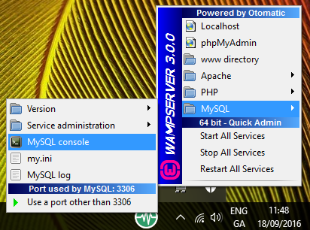

* Import the database into MySQL as follows:
  + Open the Command Prompt
  + In the Command Prompt type:

cd \wamp64\bin\mysql\mysql5.7.14\bin

* + Then type:

mysql -u root -p < "***Full Path***\superheroes.sql"

Where ***Full Path*** is the location of the superheroes.sql just downloaded.

* use superheroes;
* List all tables in the database.

show tables;

* What is the Primary Key of the superhero_no_PK table?

There is no primary key

* Show all the rows and columns in the superhero_no_PK table.

select * from superhero_no_PK;

* List all details of all superheroes in the superhero_no_PK table whose name begins with *S.*

select * from superhero_no_PK WHERE name LIKE 'S%';

* List all superheroes in the superhero_no_PK table whose Real Surname contains the letter *n.*

select * from superhero_no_PK WHERE Real_Surname LIKE '%n%';

* What is the Primary Key of the superhero_2_PK table?

describe superhero_2_pk; Name and City are primary key

* List all the details of all superheroes in the superhero_2_pk table who are male (have *man* as part of their superhero name), and who are from Gotham City

The following column names should be displayed:

HERO, city, First Name Alias, Last Name Alias.

SELECT name as "HERO", city, real_first_name as "First Name Alias", Real_Surname AS "Last Name Alias" FROM superhero_2_PK WHERE name LIKE "%man%" and city = "Gotham City";

### Part 2

* Get employeesDB100.sql from Learnonline.
* Import it into MySQL using the procedure described in Part 1.
* use employees;
* List all tables in the employees database.

show tables;

* List all Departments.

SELECT * FROM departments;

* List **only the name** of the Department d005.

SELECT dept_name FROM departments WHERE dept_no like "d005";

* List all salaries greater than or equal to 101,000, but use an alias called **money** to display the results.

SELECT salary AS money FROM salaries WHERE salary >= 101000;

* List all employees who were hired in 1987.

SELECT * FROM employees WHERE hire_date LIKE "1987%";

* List all employees who were hired in 1987 but were born in the 1960s or later.

SELECT * FROM employees WHERE hire_date LIKE "1987%" AND birth_date >= '1960-01-01';

* List the employee numbers of all employees who joined department *d005* after June 1st 1986.

SELECT emp_no FROM dept_emp WHERE dept_no = "d005" AND from_date >= '1986-06-01';

* Show the *emp_no*, *salary*, *from_date* and *to_date* of all employees who earned more than 65,000 at any time during the 1980s.

SELECT * from salaries where salary > 65000 and from_date BETWEEN "1980-01-01" AND "1989-12-31";

* List the *emp­_no*, *title*, *from_date* and *to_date* of all employees who once had the job title “Engineer”, but never progressed to “Senior Engineer” and who are still employed as an “Engineer”.

SELECT * FROM titles WHERE title = "Engineer" AND to_date = "9999-01-01";